Assets for Hands-On Lab

Creating a Windows 8 Metro Style App

Lab version: 1.0.0

Last updated: 6/15/2012

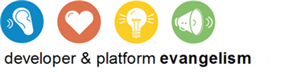

Contents

Overview 3

Overview

* 1. Assets used for hands-on labs in this training kit